**WiFi Car Controller**

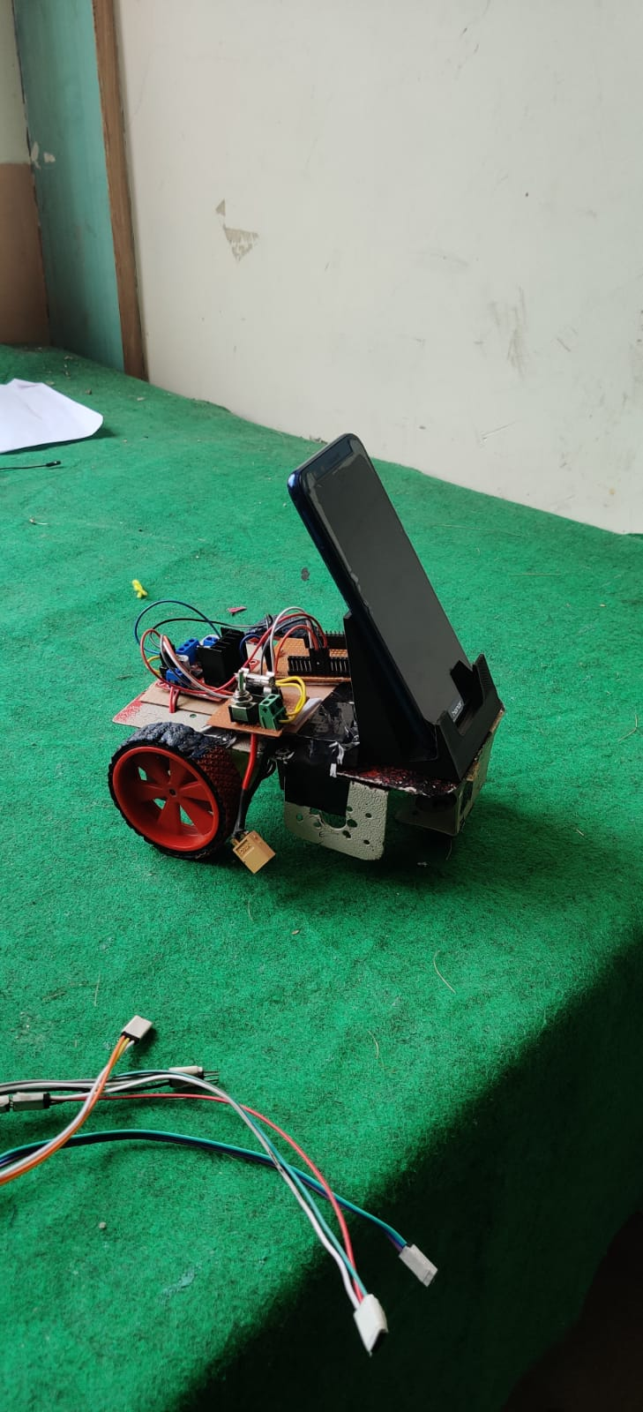

**Team Members:**

Sumeet Jadhav (Electronics And Coding)

Abhishek Raskar (Electronics And Coding)

Pranav Joshi (Electronics And Coding)

**Components:**

Esp32

L298N motor driver

2 dc motors

**Description**

For this car controller we are using esp32 module with integrated WiFi. The esp32 module can be powered from the driver module.For controlling the wifi car, we are using IoT based blynk app.